|  |  |  |
| --- | --- | --- |
| 信息与电子工程学院 | **集成电路原理与设计** | 2023年4月 |
| 2022-2023学年春夏学期 |

Table 6.1

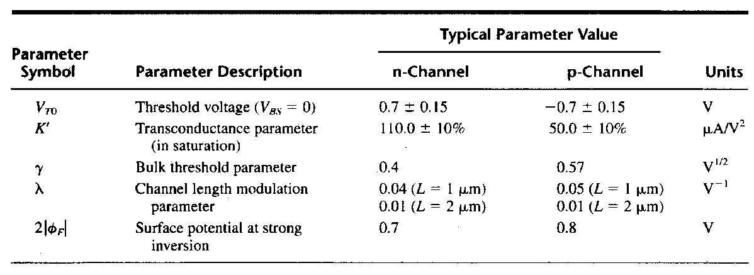

6.1 Determine *V*ref (Output Voltage) in Fig 6.1 and the conditions under which the TC of *V*ref is zero. Assume K=10. Assume (∂VT)/∂T=0.085mV/°C, (∂VBE)/∂T=-2mV/°C, VBE=0.75V, VT=26mV.

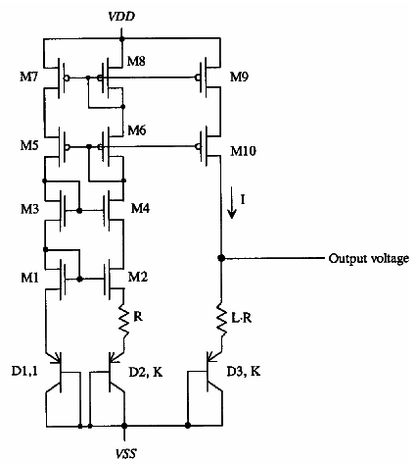

Fig 6.1

解：

For the circuit in Fig 6.1, we get

.

*V*ref is dependent on temperature and we get



 and 

Let *V*ref has zero temperature coefficient and get



It can be derived that while *L·lnK*=2/0.085=23.5，, or .

Assuming *K*=10，the corresponding *L*＝10.2≈10

Under these conditions the *Vref* that has zero TC is



6.2 Derive an expression for Iout in Fig 6.2. Assume all transistors are in saturation region, and (W/L)4=(W/L)3, λ=0.



Fig 6.2

解：



解得：

Homework for this week is a few choice questions.

6.3 A current mirror circuit is shown in Fig 6.3. In order to make Io strictly equals to Iref, what is the expression of Vb? λ=0. ( )

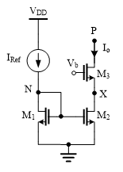

Fig 6.3

A. 2VOD + 2Vth

B. 2VOD + 2VGS

C. 2VOD + Vth

D. 2VOD

Answer: A or C

6.4 In Fig 6.3, what is the minimum value of Io? λ=0. ( )

A. 2VOD + 2Vth

B. 2VOD + 2VGS

C. 2VOD + Vth

D. 2VOD

Answer: D

6.5 How many current mirror circuit blocks exist in Fig 6.4? ( )

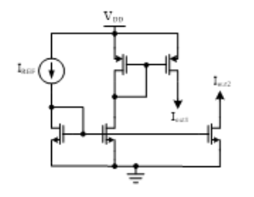

Fig 6.4

A. 1

B. 2

C. 3

D. 4

Answer: C

6.6 Assume you are an analog IC designer. When you are designing a current mirror, what device parameter should be the same to reduce mismatch? ( )

A. W

B. L

C. W/L

Answer: B